Online Doctor’s Prescription

Online doctor’s prescription is a web based application that is designed specifically to give Doctors a sigh of relief from maintaining patient records and medical history

Subscribe

**Service Costs (First 3 month is free)**

**Shared Model** this service starts from INR 12/= per prescription. Invoice is generated monthly.

**Dedicated Model** this service starts from INR 800 per month.

Details of the cost is given below-

INR 800 – Upto 100 Prescription.

INR 1500 – Upto 200 Prescription

INR 2000 – Upto 300 Prescription

INR 2500 – Upto 500 Prescription

INR 3000 – Upto 1000 Prescription

INR 5000 – Unlimited Prescription

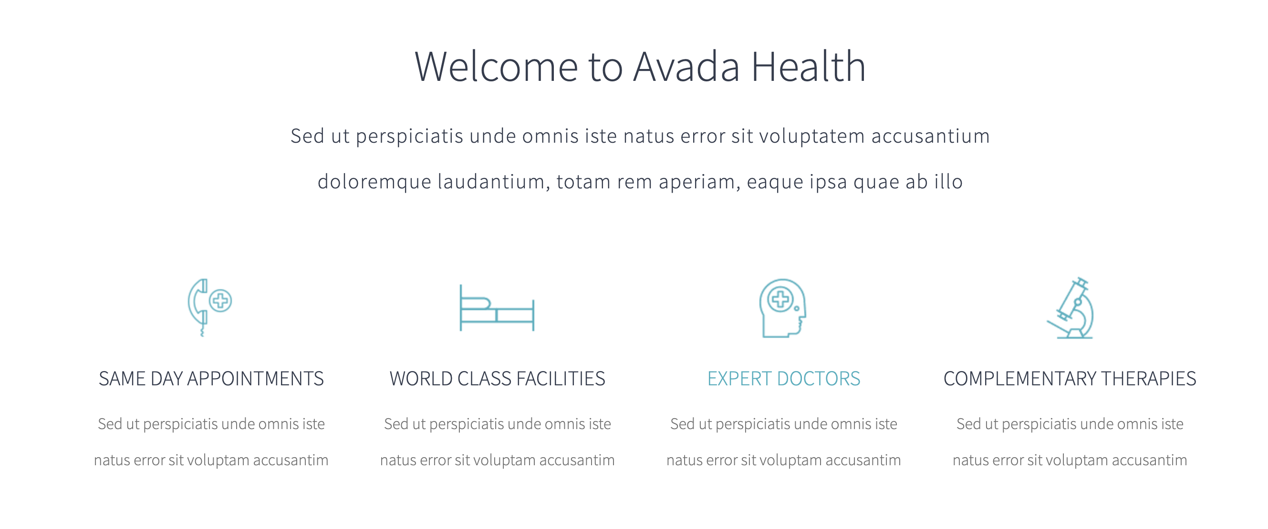

Online Doctor’s Prescription

No notepads, no letterheads, no redundant medical history queries, documenting your medical activities has never been easier.

**Digital solution**. Completely paperless

**Desktops/ Laptops** . Easily to use on desktops/ laptops with basic configuration. No fancy system requirements

**Web based application**. No download required

**For Doctors** Suitable for private practices and medical institutions

Participating Doctors

From last 5 years. Many doctors are participating in our solutions.

We are grateful for few of them with their inputs in creating this solution.

These three doctors are pioneering towards making the solution for last 5 years.

Dr. Soumyabrata Roy Chaudhuri (Consultant Diabetologist)

Dr. Debmalya Sanyal (Consultant Diabetologist)

Dr. Hindol Dasgupta (Cardiologist)

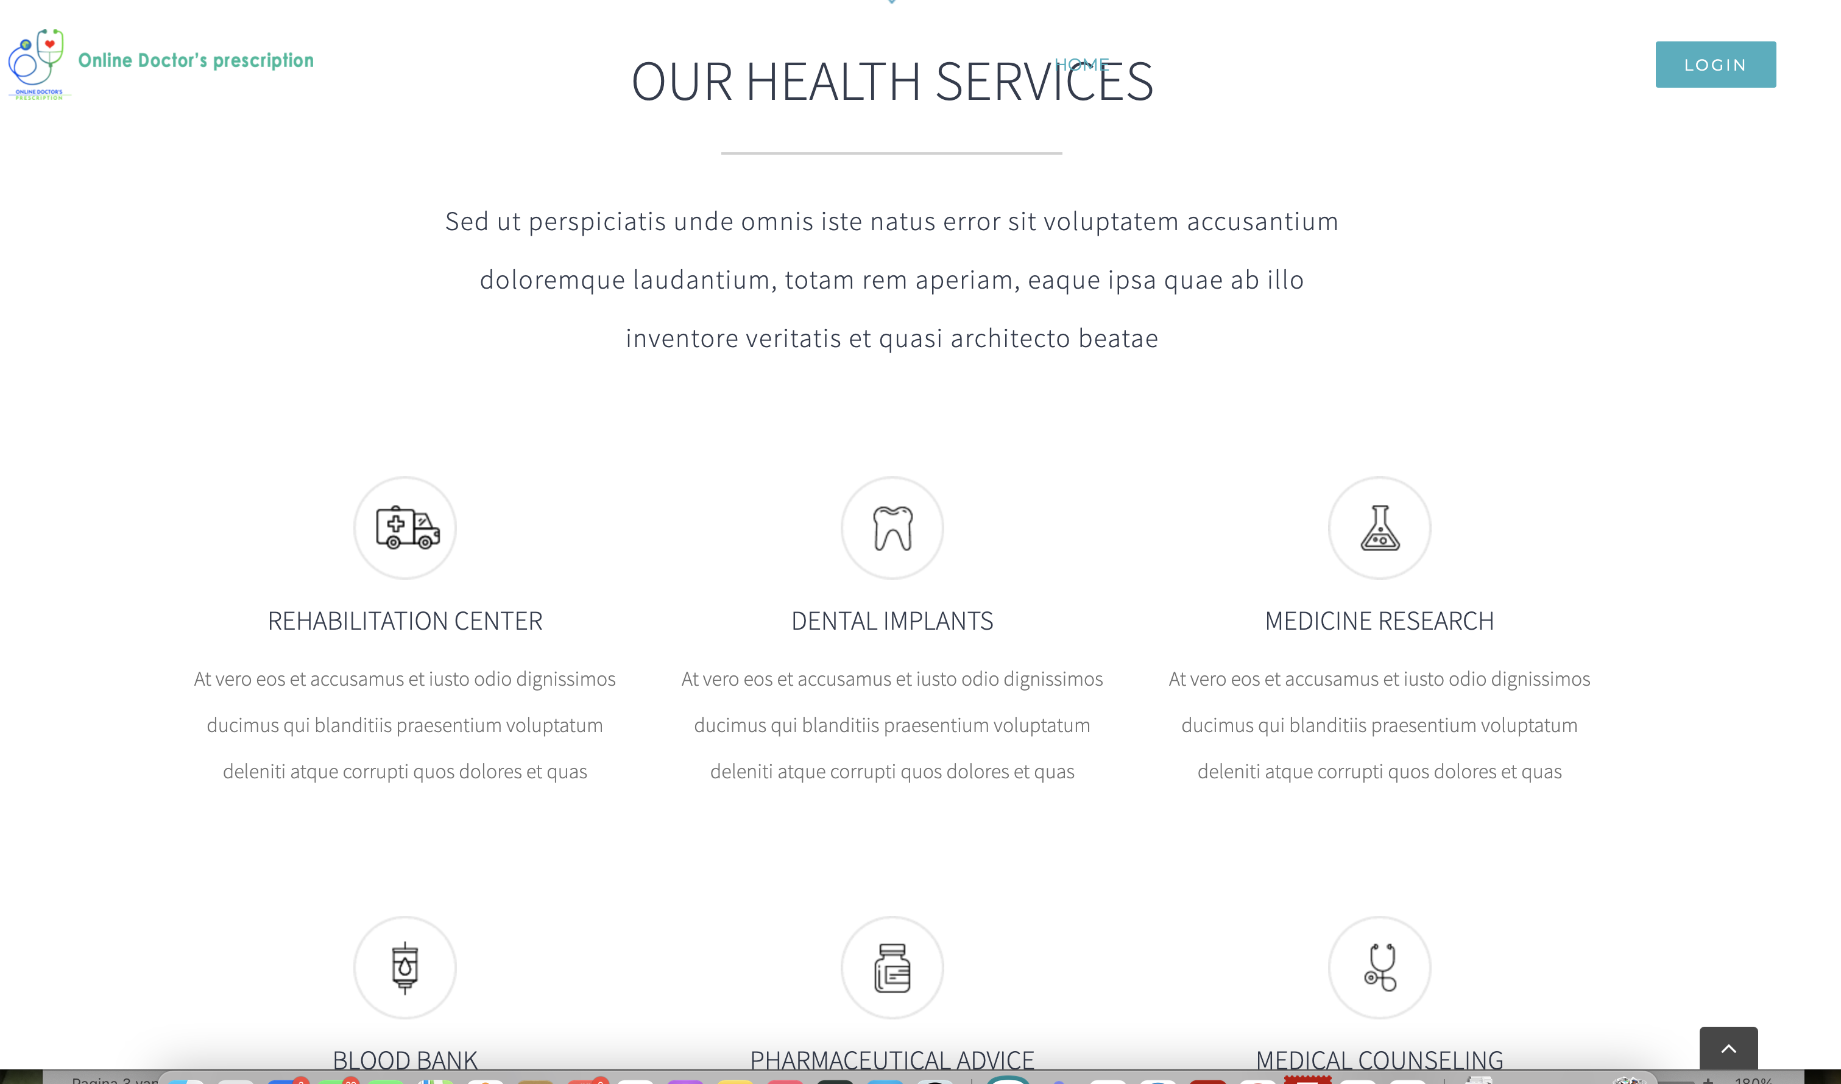

**Why Us** :  
Online Doctor Prescription is a web based application that is designed specifically to keep doctors busy in what they do best. No notepads, no letterheads, no redundant medical history queries, documenting your medical activities has never been easier.   
  
Digital solution. Completely paperless  
Easily to use on desktops/ laptops with basic configuration. No fancy system requirements  
Web based application. No download required  
Records all past medical history of patients, saving all the unnecessary queries and miscommunications. No misleading reports  
Unique patient identity generation. No confusion with same names  
A copy of the prescription gets emailed to the patient right away  
No chances of losing a prescription ever again  
User friendly interface. Suitable for doctors across all specializations  
Customizable and flexible to suit specific of individual doctors  
Suitable for private practices and medical institutions

The Complete solution

Easy and comprehensive solution which caters the need of a medical practitioner.

<https://www.youtube.com/watch?v=ER8sS3ENOLE&t=4s>

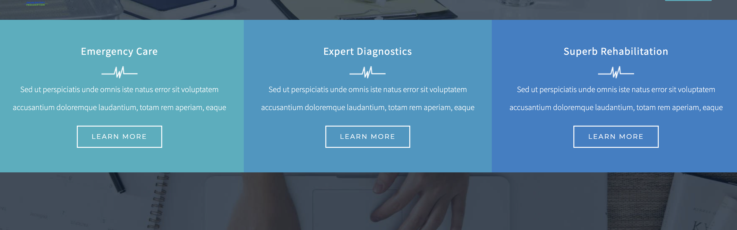

No notepads - documenting your medical activities has never been easier

no letterheads - it saves a copy for you too! Just look up for the unique ID for each patient and you have all the details at a click.

no redundant medical history queries - Just type in the details and the prescription gets emailed to the patient instantly

**Subscribe yourself Digitally**

You’re just a click away before you subscribe yourself.

Subscribe yourself with few clicks. First 3 months of subscription is absolutely free.

We can tailor your subscription according to your need.

Online Doctor’s Prescription

Online doctor’s prescription is a web based application that is designed specifically to give Doctors a sigh of relief from maintaining patient records and medical history

Subscribe

Contact Information

* Messiaenplantsoen 114, 1323 LJ, Almere, The Netherlands
* +31 682326496
* [admin@myeprescription.in](mailto:admin@myeprescription.in)

Our Partnar

P.G.INFO SERVICES PVT. LTD.(www.prginforservices.com

+91 9564216736

**ADOPT ENDOCRINE Diabetes Clinic (**[**https://treatdiabetes.co.in**](https://treatdiabetes.co.in)**)**